FORME Clothing Store Project Report
  - College Laboratory Project Documentation
FORME is a full stack clothing store built with MongoDB, Express, React and Node.js. A shopper can browse size-specific stock, request size guidance, place a cash-on-delivery order and track it from an account. The same application lets members review products and vote on outfits, while administrators manage inventory, fulfilment and moderation.

Project Aim
Build a working online clothing store that demonstrates how a React interface, an Express API and a MongoDB database coordinate a complete shopping journey. The project also demonstrates how authenticated community features and an administrator interface can share the same catalogue and customer records.

Project Objectives
Storefront and fit. Make catalogue items easy to find, show available sizes and offer size and outfit suggestions.
Reliable checkout. Calculate prices on the server and keep order creation, stock changes and coupon redemption consistent.
Customer participation. Provide account controls, product reviews with optional photos and outfit posts with time-limited voting.
Store administration. Give authorised staff tools for products, stock, coupons, orders, customers and content moderation.

Report Contents
Pages | Topic
2–3 | System architecture diagram and project file structure
4 | Data model, authentication and privacy
5 | Website routes and API reference
6 | Local setup, verification and deployment
7–13 | Website sequence diagrams and flow explanations

Project scope: sample clothing catalogue, INR pricing and cash on delivery. Size guidance is an estimate. The application does not collect online payments.

01

Architecture and File Structure
The browser loads the React single-page app and talks to the same origin under /api. React Router selects the page, StoreContext shares catalogue, session and bag state, and the API client sends credentials and the CSRF token when needed. Express validates requests and applies business rules. Mongoose maps those rules to documents and transactions in MongoDB Atlas.

Source Tree
forme-clothing-store/
|-- server.ts Local dev and standalone server
|-- api/index.ts Vercel API entry point
|-- backend/
| |-- app.ts Main Express app and route wiring
| |-- database.ts Connection and database initialisation
| |-- models.ts Mongoose schemas and indexes
| |-- commerce.ts Quotes, order placement and status changes
| |-- community.ts Sizing, reviews, face-offs and media routes
| |-- media.ts Image processing, storage and attachment
| |-- security.ts Sessions, authorisation, CSRF and limits
| |-- neon-auth.ts Google identity verification and linking
| |-- domain.ts Input rules, pricing and shipping checks
| |-- validation.ts Request validation and unsafe key rejection
| |-- privacy.ts Account deletion and order anonymisation
| +-- catalog.ts et al. Demo catalogue and catalogue migrations
|-- src/
| |-- main.tsx / App.tsx React entry point and site routes
| |-- store/ Page components, API client and shared state
| |-- styles/ Storefront, community and responsive CSS
| +-- utils/ Browser and server helper functions
|-- shared/ Sizing, outfit matching and password helpers
|-- public/catalog/ Bundled sample product photos
|-- scripts/ Setup, diagnostics and live verification
|-- docs/ Deployment, features, sizing and attribution
|-- .github/workflows/ Continuous integration checks
+-- package.json, vite.config.ts, vercel.json, .env.example

Where to Start Reading
Begin with App.tsx and StoreContext.tsx to see how pages and browser state connect. Follow a request into backend/app.ts or backend/community.ts, then open its service and schema. For checkout, read Checkout.tsx, commerce.ts and models.ts in that order.
The tree groups related files and omits generated output, installed dependencies and private configuration.

01 SYSTEM ARCHITECTURE

Application Architecture Diagram
FORME has three core layers: a React site in the browser, an Express API that applies store rules, and MongoDB Atlas for persistent data. Neon Auth and Google supply identity when configured.
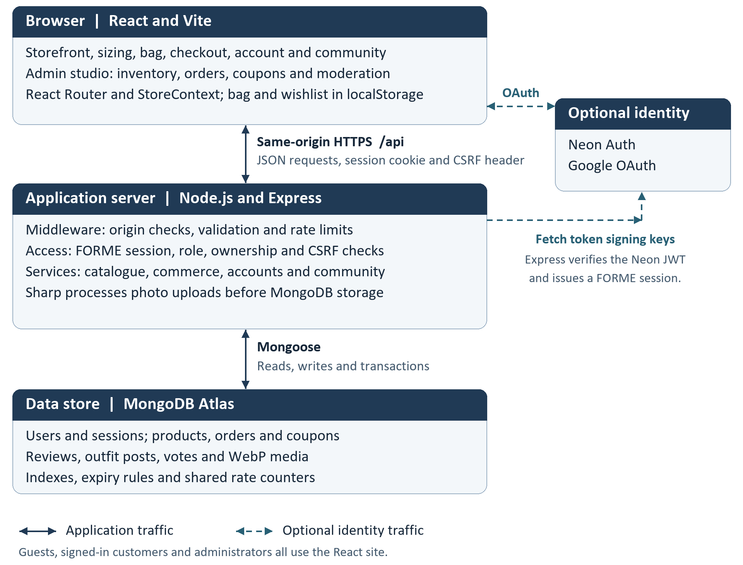
Architecture figure. Solid arrows connect the application layers. Dashed arrows show the optional Google sign-in path.
Hosting. Vercel serves the built React site and rewrites API requests to the Express function. In local development, Express runs with Vite middleware. A standalone production server serves the built site and API together.
System of record. MongoDB stores catalogue, order, account and community data, including uploaded photos. Neon handles Google identity. FORME still keeps the application user, role and session in MongoDB.
Code references: server.ts, vercel.json, api/index.ts, src/App.tsx and backend/app.ts, database.ts, neon-auth.ts.

02

Data Model and Access Controls
Collection | Purpose and relationships
users | Email, profile, password hash or Google identity link, role and active session slots.
products | Public product ID, category, INR price, active flag and stock per size. Inventory revisions guard admin edits.
orders | Customer reference, delivery address, product and price snapshots, payment and fulfilment status. The user and request ID pair is unique.
coupons | Discount rules, validity and redemption limits. Tracks which accounts used a code.
reviews | Rating, text, optional images and delivered-purchase badge. One review per account and product.
faceoffs and votes | Posts contain labelled outfit options and a closing time. A vote references a post and a member; the pair is unique.
media | WebP image bytes, owner, attachment and timestamps. Unattached drafts expire through a TTL index.
rate_limits and migrations | Shared API counters and records of applied catalogue migrations.

Identity and Permissions
A visitor can read the public catalogue, reviews and outfit feed. A signed-in customer can order, publish and manage their own records. Administrative routes check the role in MongoDB; ownership checks protect individual customer records.
The API issues a signed JWT in an HttpOnly, SameSite cookie. It checks the matching database session on protected requests. A session expires after eight hours; issuing a fourth session removes the oldest slot. Protected writes normally require the session-bound X-CSRF-Token header. Request validation, origin checks and shared rate counters constrain API access.

Privacy and Retention
Passwords are stored as salted scrypt hashes. Sizing measurements are used to compute a suggestion and are not saved. Published community photos are public; unattached uploads are private. Account deletion removes the profile and community data and anonymises retained order records. A shipped order blocks deletion until resolved.
Code references: backend/models.ts, security.ts, community.ts and privacy.ts.

03

Website Routes and API Reference
Website route | What opens
/ and /shop | Landing page and searchable catalogue.
/product/:id | Product details, size guidance, available variants and reviews.
/checkout and /order/:id | Checkout and order confirmation.
/community | Public outfit feed, posting, voting and own posts.
/account | Orders, profile, security and session controls.
/admin and /admin/community | Store administration and community moderation.
/auth/callback | Completes the optional Google sign-in or account link.

Representative API Operations
Paths below are relative to /api. Public reads include product data, reviews and the outfit feed. Checkout, account, voting, publishing and administrative actions require the appropriate identity.
Operation | Method and path
Identity | POST /users, POST /login, POST /auth/neon, GET /session, POST /logout
Account | GET, PUT, PATCH or DELETE /users/me; GET /users/me/dashboard; GET /users/me/sessions; DELETE /users/me/sessions/:id
Products and size | GET /products, GET /products/:id, POST /size-recommendation
Commerce | POST /checkout/quote, GET or POST /orders, PATCH /orders/:id/cancel
Reviews and media | GET /products/:productId/reviews; PUT or DELETE /products/:productId/reviews/me; POST /media; GET /media/:id
Outfit feed | GET or POST /faceoffs; PUT /faceoffs/:id/vote; DELETE /faceoffs/:id
Administration | /admin/dashboard, /admin/products, /admin/orders, /admin/customers, /admin/coupons, /admin/community and review removal
Readiness | GET /health
Code references: src/App.tsx, backend/app.ts and backend/community.ts.

04

Setup Verification and Deployment

Run Locally
Use Node.js 22.x and npm. Prepare a MongoDB Atlas database with the access needed to create indexes and run transactions. From the project root, copy .env.example to .env. Set MONGO_URI and a strong JWT_SECRET of at least 32 characters, and set MONGO_DB_NAME if you use a custom database name.
npm ci
npm run env:check
npm run db:setup
npm run dev
Open http://localhost:3000 unless PORT is set to another value. Check /api/health for HTTP 200 and status "ok". Database setup installs indexes and applies the catalogue migrations. To provision a local administrator, set ADMIN_EMAIL and run npm run admin:setup.

Verify a Demonstration
Check | What to look for
npm run check | Repository audit, TypeScript checks, unit tests and production build.
Customer journey | Register or sign in, select a stocked size, request a quote and place a test COD order. Confirm it appears in the account.
Admin and community | Move a test order to Delivered; save a review and check the badge. Upload an outfit, vote from another account and check moderation.
Live integration commands | test:atlas, test:media and test:neon verify API commerce, uploaded media and identity behaviour against a configured environment.

Production Options
For standalone hosting, run npm run build and npm start. On Vercel, the frontend is built into dist and API requests are rewritten to api/index.ts. Initialise MongoDB before the first deployment. Static browser routes use the SPA fallback, while /api paths reach Express.
Google sign-in is optional. Set NEON_AUTH_URL and VITE_NEON_AUTH_URL to the same Neon Auth URL, configure Google in Neon, and allow the exact application origin. Keep database credentials, JWT secrets and provider secrets out of the browser build.
Further reading: docs/DEPLOYMENT.md, docs/FEATURE_STATUS.md, docs/SIZING.md and VERIFICATION.md.

05 WEBSITE SEQUENCE OVERVIEW

End to End Website Sequence
This overview follows a sample shopper from browsing to a delivered order, then shows how the order connects to reviews and how the same account can participate in the outfit feed.
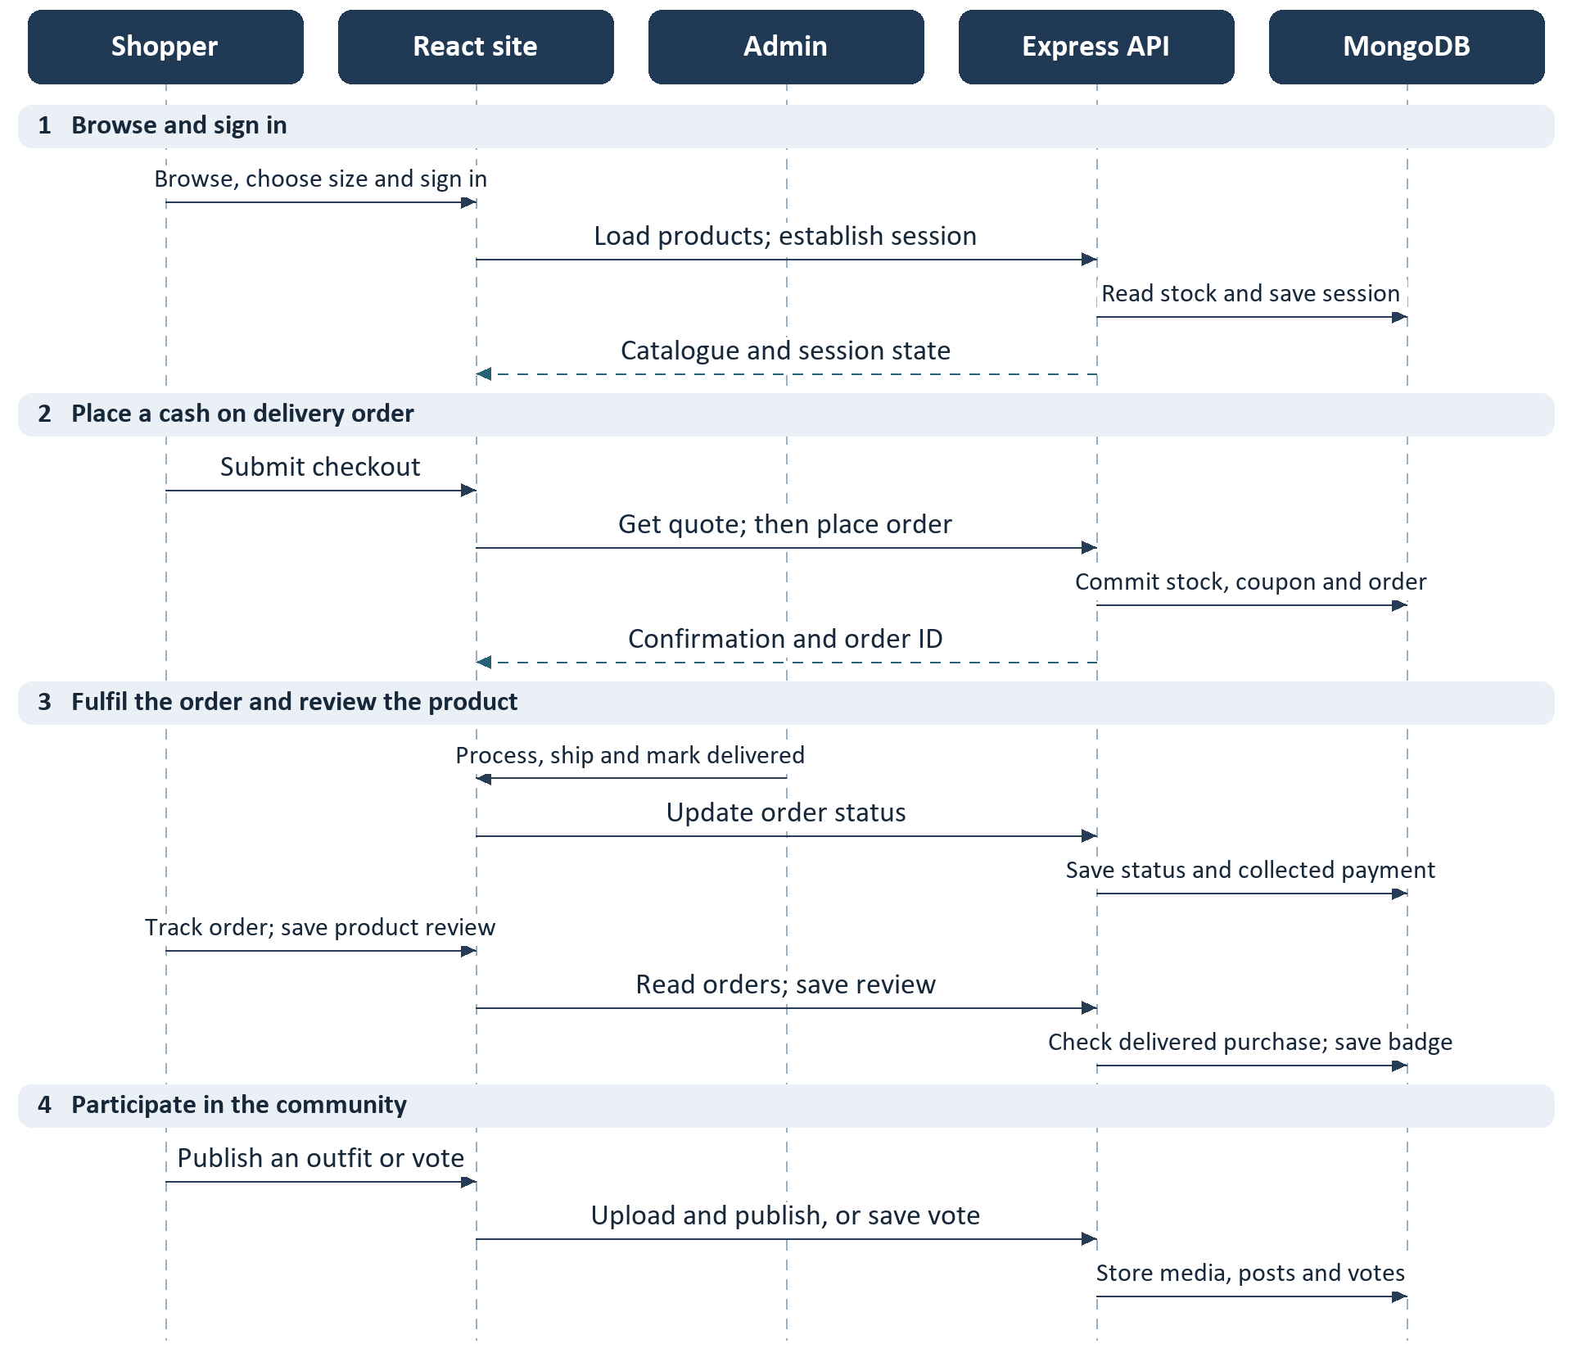
Overview. Read from top to bottom. Solid arrows send requests or actions; dashed arrows return results.
Shared records. The product selected in the storefront becomes an order item. A delivered order can qualify the customer’s later review for a verified badge. The customer’s existing session also authorises community actions.
Detailed diagrams. Figures 1 to 6 expand the calls, decisions and alternatives. Community participation is optional and does not require a purchase.
Code references: src/App.tsx, src/store and backend/app.ts, commerce.ts, community.ts.

05 SEQUENCE DIAGRAM 1

Storefront to Checkout
The shopping journey starts with a public catalogue. The browser can keep a bag before the shopper signs in, then passes the selected items to authenticated checkout.
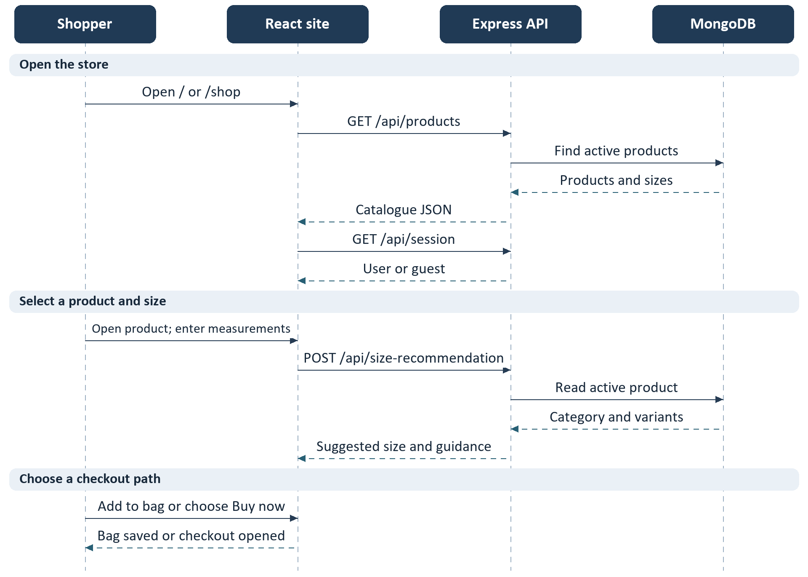
Figure 1. Read from top to bottom. Solid arrows send requests or actions; dashed arrows return results.
Bag and wishlist. StoreContext saves the bag and wishlist in browser localStorage. The bag checks the selected variant against the stock shown in the catalogue. It can also suggest complementary in-stock pieces. This check does not reserve stock.
Checkout handoff. Buy now passes one item in router state; the bag route uses the saved bag. Checkout requires a FORME session. Figure 2 covers sign-in and Figure 3 covers the quote and order.
Code references: src/store/StoreContext.tsx, Catalogue.tsx, Layout.tsx and backend/community.ts.

05 SEQUENCE DIAGRAM 2

Sign In and Session Creation
Both password and Google sign-in end in the same FORME session. Only the Google path sends the browser through the configured identity provider.
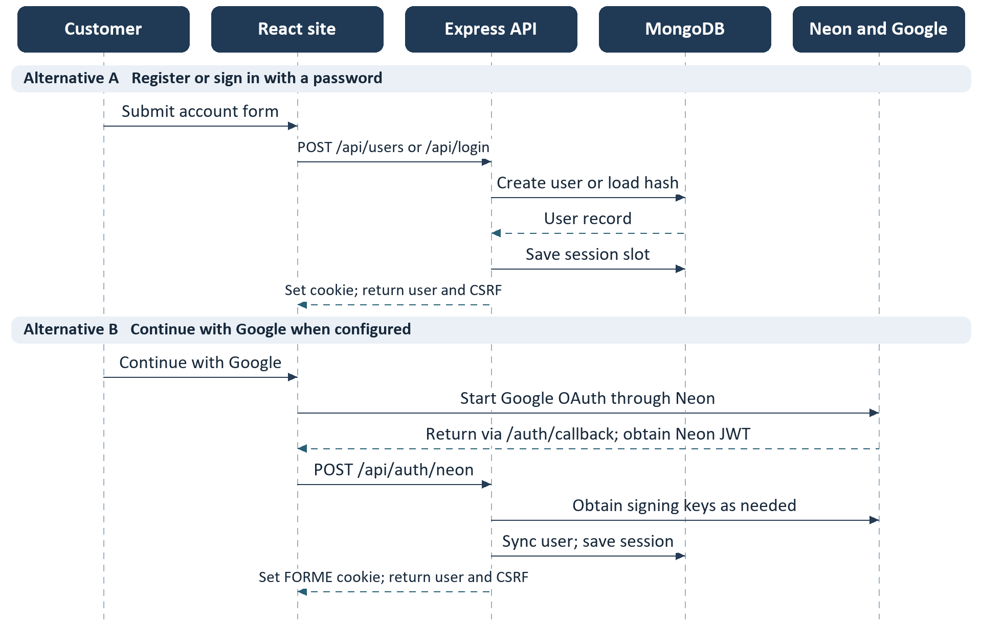
Figure 2. Read from top to bottom. Solid arrows send requests or actions; dashed arrows return results.
Account linking. An existing password account must sign in locally before connecting the same Google email. Express verifies the Neon token and matches or creates the MongoDB customer. Roles are read from MongoDB.
Following requests. The browser sends the cookie to Express. The API client supplies the CSRF header for protected writes. An expired or revoked session must be renewed by signing in again.
Code references: src/store/Auth.tsx, neon.ts, GoogleCallback.tsx and backend/app.ts, neon-auth.ts, security.ts.

05 SEQUENCE DIAGRAM 3

Checkout and Order Placement
The quote displays current server prices, coupon discount and delivery. Submitting the order repeats the checks and writes inventory, coupon and order changes in one transaction.
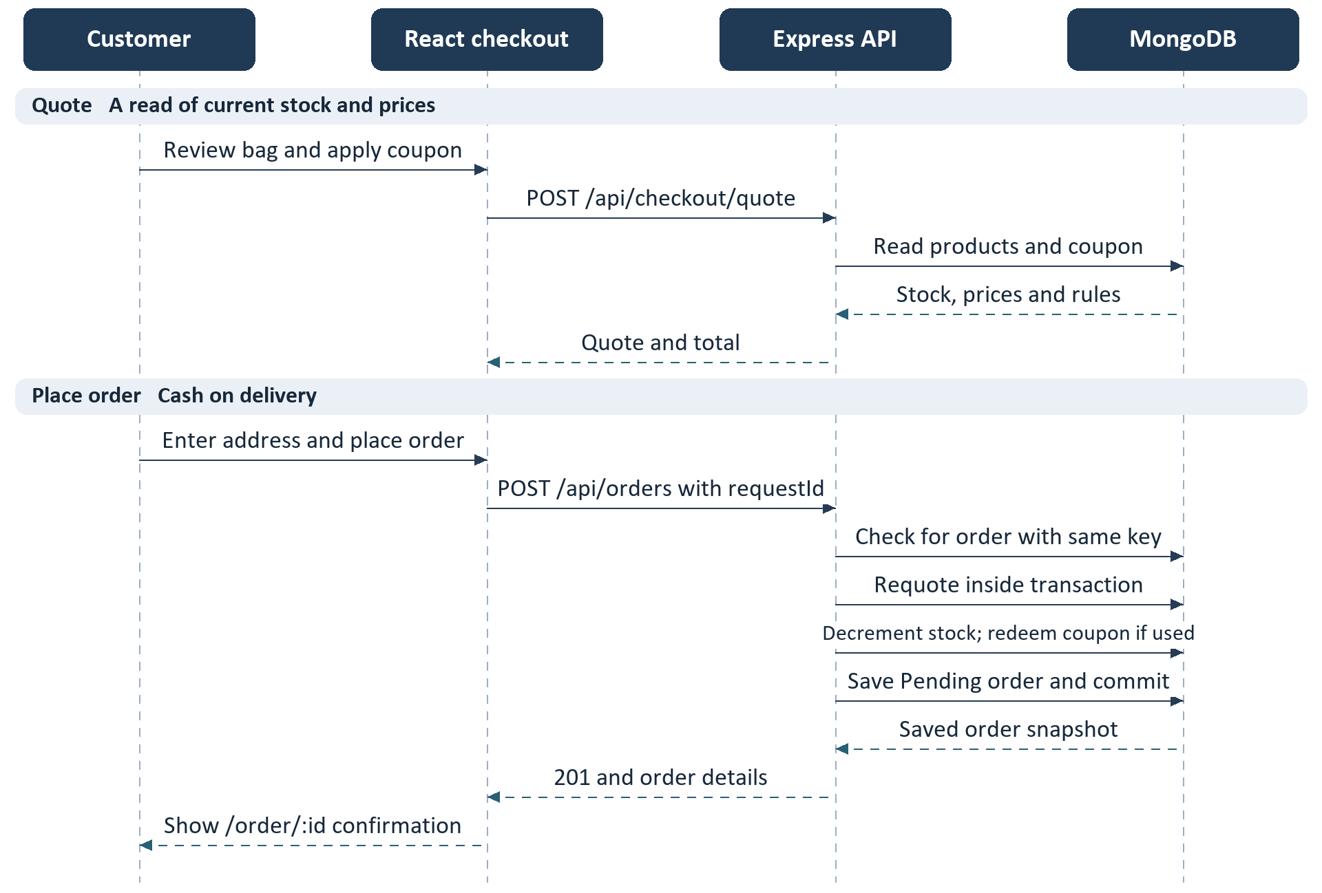
Figure 3. Read from top to bottom. Solid arrows send requests or actions; dashed arrows return results.
Retry branch. If the same customer retries with the same request ID, the server can return the existing order without decrementing stock again. If the selected size sells out or a coupon becomes unavailable, the transaction aborts and the site displays an error.
After success. Bag checkout clears the bag; Buy now leaves it intact. The site refreshes the catalogue and navigates to confirmation. The order remains unpaid until the administrator marks it Delivered.
Code references: src/store/Checkout.tsx and backend/app.ts, commerce.ts, domain.ts, models.ts.

05 SEQUENCE DIAGRAM 4

Fulfilment and Order Cancellation
The admin studio changes fulfilment status, and the customer dashboard reads the same order record. A customer can cancel only their own eligible order.
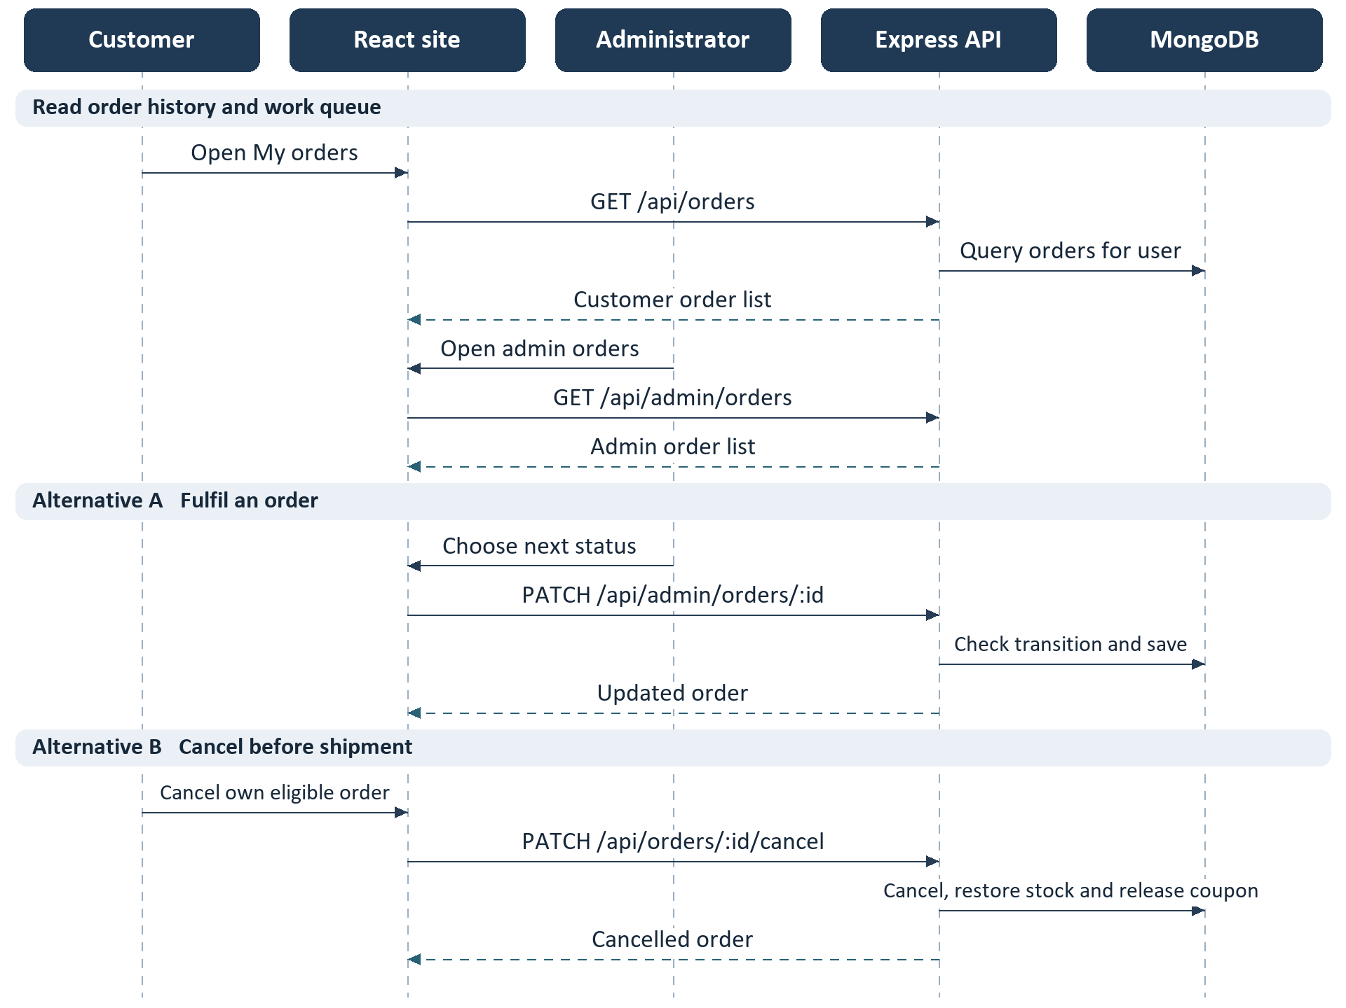
Figure 4. Read from top to bottom. Solid arrows send requests or actions; dashed arrows return results.
Order rules. The normal path is Pending → Processing → Shipped → Delivered. Cancellation is available from Pending or Processing. Delivered and Cancelled are terminal. Delivery marks COD payment as collected.
Inventory and admin controls. Administrators can also create, edit and archive products, manage coupons and view customer and earnings summaries. Product updates include an inventory revision so an old edit cannot silently overwrite changed stock.
Code references: src/store/Account.tsx, Admin.tsx and backend/app.ts, commerce.ts.

05 SEQUENCE DIAGRAM 5

Reviews Photos and Outfit Voting
Reviews and outfit posts use a shared photo pipeline. Uploaded photos stay private until a successful publish request attaches them to a review or post.
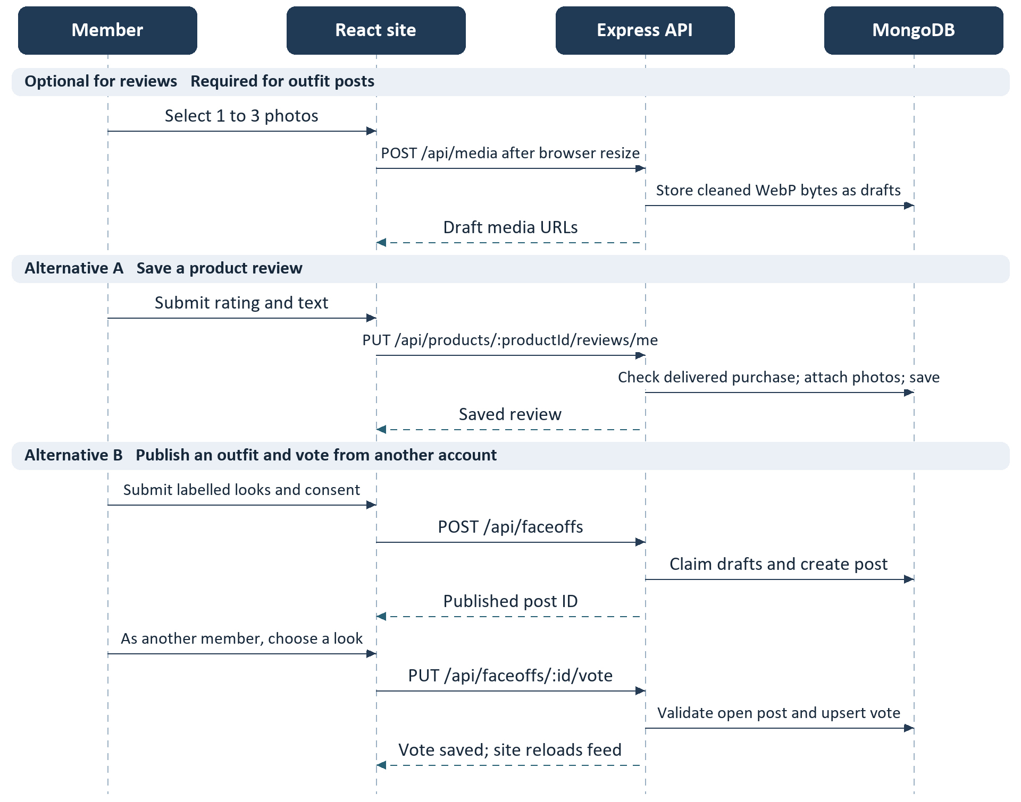
Figure 5. Read from top to bottom. Solid arrows send requests or actions; dashed arrows return results.
Publication rules. Sharp re-encodes uploads as WebP, strips metadata and enforces the server size limits. Public image GET requests only return attached images. Each review may have up to three photos and can display a verified badge for a delivered order.
Community rules. A member can change one vote per post until its seven-day window closes, and cannot vote on their own post. Owners can delete their posts; administrators can remove posts or reviews through moderation.
Code references: src/store/Photos.tsx, Community.tsx, Wardrobe.tsx, Moderation.tsx and backend/community.ts, media.ts.

05 SEQUENCE DIAGRAM 6

Account Management and Deletion
The account dashboard gathers orders, reviews, posts and votes for the signed-in user. Profile and session operations share the same owner-scoped API as account deletion.
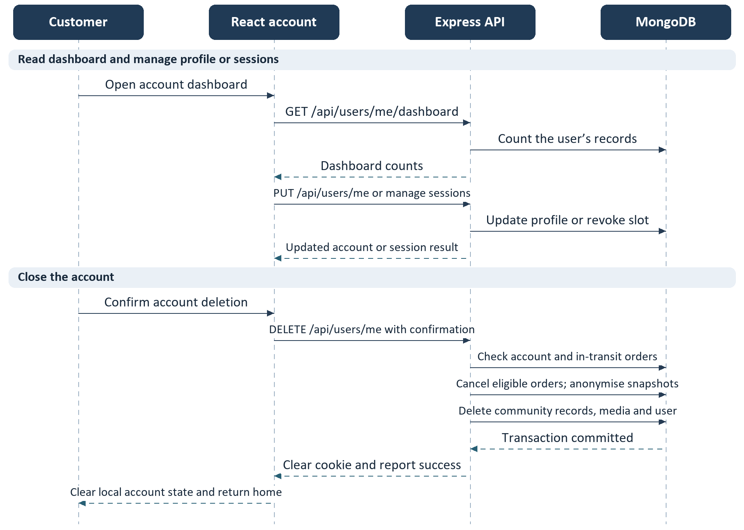
Figure 6. Read from top to bottom. Solid arrows send requests or actions; dashed arrows return results.
Confirmation and conflicts. Password accounts confirm with their current password; Google-only accounts provide a verified token for the linked identity. If a shipped order is still in transit, the API rejects deletion and keeps the account intact.
What remains. Eligible cancellations restore inventory and release coupon use. Retained order snapshots lose the original user link, name, email and address. Deleting the user removes the stored session slots.
Code references: src/store/Account.tsx, Sessions.tsx and backend/app.ts, community.ts, privacy.ts.

